Divvy Bike-Share Case Study

Data Analysis Life Cycle: From Source SQL to Tableau Storytelling

Phase 1: Ask
The primary business objective is to analyze historical Divvy bike-share trip data over a full trailing 12-month period to identify distinct behavioral differences between casual riders and annual members. By unlocking these behavioral trends, the marketing team can design a data-driven conversion strategy targeted at converting casual riders into long-term subscribers.
Key Strategic Question:
How do annual members and casual riders use Divvy bikes differently, and what marketing triggers will incentivize a casual rider to purchase an annual membership?

Phase 2: Prepare
Data sourcing involved 12 distinct monthly CSV files extracted from zipped raw transactional archives. These files were compiled, normalized, and uploaded via a sequential staging pipeline into a MySQL relational database ecosystem for secure storage and structured querying.

Query 2.1: Master Dataset Row Audit
Executed to cross-examine total loaded database records against source CSV tallies:
SQL
SELECT COUNT (*) AS total_rides FROM bikes

Metric | Rows Returned
total_rides | 5,848,703

Phase 3: Process
Before finalizing operational insights, data verification and cleaning protocols were implemented to isolate anomalies. This processing step addressed systemic false starts (trips lasting less than 60 seconds) and database processing errors resulting in negative trip durations (where the trip end timestamp precedes the start timestamp), ensuring an unskewed dataset for downstream visualization.

Phase 4: Analyze
Core Exploratory Data Analysis (EDA) was performed via SQL server aggregates to extract behavioral baselines across user segments.

Query 4.1: Rider Segment Proportions
Calculates the relative distribution of volume across user types:
SQL
SELECT member_casual, COUNT (*) AS total_rides,
(COUNT (*) * 100.0 / (SELECT COUNT(*) FROM bikes),2) AS percentage entage
FROM bikes
GROUP BY member_casual;

member_casual | total_rides | percentage
casual | 2,100,265 | 35.91%
member | 3,748,438 | 64.09%

Query 4.2: Trip Duration Metric by Segment
Determines the average trip time in minutes via timestamp intervals:
SQL
SELECT member_casual, ROUND(AVG(TIMESTAMPDIFF(MINUTE, started_at, ended_at)), 2) AS avg_duration_minutes
FROM divvy_trips GROUP BY member_casual;

member_casual | avg_duration_minutes
member | 11.98
casual | 21.77

Query 4.3: Weekly Usage and Seasonality Profile
Tracks behavioral differences aggregated across the days of the week:
SQL
SELECT member_casual, DAYNAME(started_at))AS day_of_week, COUNT(*) AS total_rides FROM divvy_trips GROUP BY member_casual, day_of_week ORDER BY member_casual, FIELD(day_of_week, 'Sunday', 'Monday', 'Tuesday', 'Wednesday', 'Thursday', 'Friday', 'Saturday');

Day of Week | Member Rides | Casual Rides
Sunday | 414,395 | 360,308
Monday | 527,257 | 245,259
Tuesday | 592,543 | 234,846
Wednesday | 594,444 | 236,518
Thursday | 601,521 | 267,111
Friday | 548,705 | 323,399
Saturday | 469,573 | 432,824

Query 4.4: Geographical Hotspot Analysis (Casual Riders)
Top 10 historical starting docking stations utilized exclusively by casual riders to maximize marketing conversion efficiency:
Rank | Start Station Name | Total Casual Rides
1 | Navy Pier | 38,364
2 | DuSable Lake Shore Dr & Monroe St | 32,263
3 | Michigan Ave & Oak St | 22,887
4 | DuSable Lake Shore Dr & North Blvd | 19,888
5 | Millennium Park | 18,821
6 | Shedd Aquarium | 16,861
7 | Theater on the Lake | 16,272
8 | Dusable Harbor | 15,338
9 | Streeter Dr & Grand Ave | 14,981
10 | Michigan Ave & 8th St | 11,055

Phase 5: Share
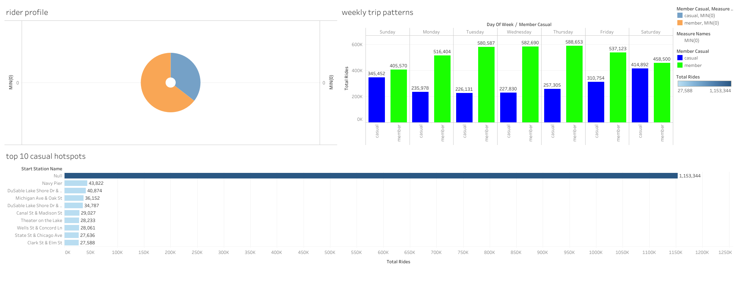Phase 6: Act (Strategic Recommendations)
• Message Shift (Highlights Savings): Pivot marketing from work commutes to weekend leisure. Showing casual riders (who average 21.77-minute trips) that a membership is cheaper than single-ride fees turns a hobby into an obvious financial win.
• Targeted Ads (Eliminates Waste): Concentrate physical signs and promo teams strictly at top casual hubs. Focusing the budget on hotspots like Navy Pier, DuSable Lake Shore Dr, and Millennium Park guarantees we hit the target audience without wasting ad spend.
• Smart Alerts (Captures Peak Intent): Trigger a single-click membership discount via the app the exact moment a rider locks their bike at a Top 10 station. This catches users at peak satisfaction, removing friction and driving immediate upgrades.

